Game Design Document

Fill up the Following document

1. Write the title of your project.

* FISH RESCUE!!!

1. What is the goal of the game?

* To spread awareness about the aquatic life that we should not throw the waste trash in any of the water bodies.

1. Write a brief story of your game?

* The story is about a fish in one ocean and there is some trash in

the ocean and also there is some food to increase its life.

And if the fish touches any of the trash its life will keep on decreasing.

1. Which are the playing characters of this game?

* Playing characters are the ones which respond to the user based on the input from the user
* Cars, monkeys, dinos, wizards etc, are the playing characters in the game.

|  |  |  |
| --- | --- | --- |
| Number | Character Name | What can this character do? |
| 1 | FISH | This character can be controlled with the help of UP and DOWN arrow KEYS. |
| 2 |  |  |
| 3 |  |  |
| 4 |  |  |
| 5 |  |  |
| 6 |  |  |
| 7 |  |  |
| 8 |  |  |

1. Which are the Non Playing Characters of this game?

* Non Playing characters are the ones which don't have an action or a behaviour when the user interacts with the game.
* Hurdles, stones, bananas, coins, etc are non playing characters in the game.

|  |  |  |
| --- | --- | --- |
| Number | Character Name | What can this character do? |
| 1 | SOME OTHER CREATURES | This adds attraction to the game. |
| 2 | TRASH | If PC touches this character, PC will lose its lives. |
| 3 | FISH FOOD | This will increase the score of the game. |
| 4 |  |  |
| 5 |  |  |
| 6 |  |  |
| 7 |  |  |
| 8 |  |  |

Draw your imagination of this game. What does this game look like?

* Draw the game either on your computer or on paper,
* Add images of scenes of the game to show each of the playing and non-playing characters at least once.

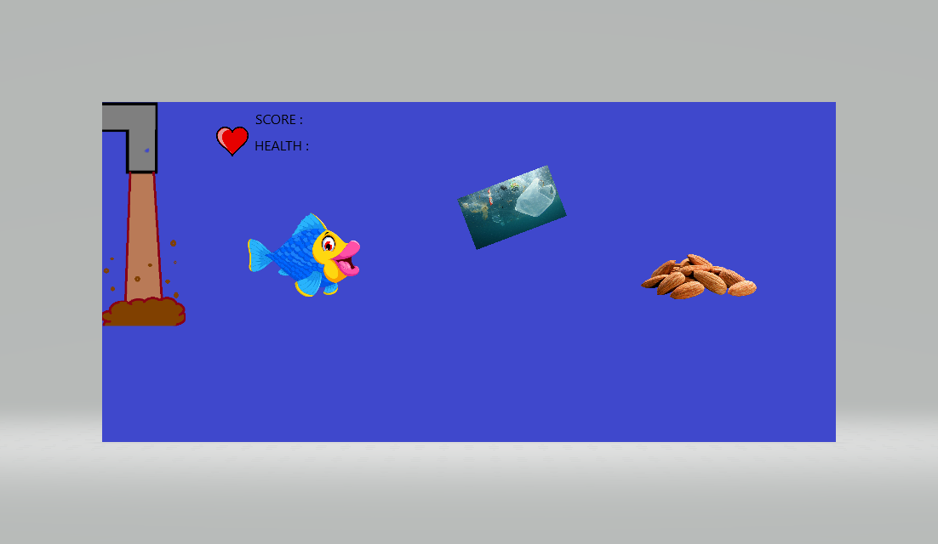

MY GAME WILL BE SOMETHING LIKE THIS…

How do you plan to make your game engaging?

* I am planning to make the game engaging by adding some lives to the game. So that if the player touches any trash it has next chances to play.